

**International University of Business Agriculture and Technology**

**(IUBAT University)**

**Project name**

Student Result Management System

**Prepared For:**

**Safwana Haque**

Course Instructor

Department of Computer Science and Engineering

(IUBAT University)

**Course Code**

CSC 383

**Prepared By:**

Group number- 3

|  |  |
| --- | --- |
| Name | ID |
| Md. Erfan Ullah Bhuiyan | 15103325 |
| MD Rafiqul Islam Khan | 15103339 |
| Md. Ashfaq Uddin | 15103341 |
| Kaniz Fatema | 15103342 |
| Rafia Mohol Anni | 15103340 |

**Submission Date: 07-04-2017**

# Table of Contents:

Table of Contents: 2

List of Figures: 3

Introduction 4

1.1 Software design requirement: 5

1.2 Aims and Objectives: 5

Design and Implementation 6

2.1 Design Approach: 6

2.2 UML Class Diagrams: 7

2.3 Database and Table Design: 14

2.4 Graphical User Interface Implementation 15

Critical Evaluation 21

Bibliography: 22

# List of Figures:

Figure 2.2.1: Student.java 9

Figure 2.2.2: Login.java 9

Figure 2.2.3: Adminpanel.java 10

Figure 2.2.4: C_insert.java 10

Figure 2.2.5: C_list.java 11

Figure 2.2.6: AssignCourse.java 11

Figure 2.2.7: Scourse.java 12

Figure 2.2.8: F_insert.java 12

Figure 2.2.9: Jtable.java 13

Figure 2.2.10: S_insert.java 14

Figure 2.2.11: S_list.java 14

Figure 2.2.12: F_pinfo.java 14

Figure 2.2.13: F_panel.java 15

Figure 2.2.14: S_pinfo.java 15

Figure 2.2.15: S_panel.java 16

Figure 2.4.1: Login page 17

Figure 2.4.2: Admin information 18

Figure 2.4.3: Adding Faculty 19

Figure 2.4.4: Faculty List 19

Figure 2.4.5: Adding new Student. 19

Figure 2.4.6: Student List. 20

Figure 2.4.7: Add course Window 20

Figure 2.4.8: Course List 21

Figure 2.2.9: Assign Course 21

Figure 2.4.10: Faculty Profile 22

Figure 2.4.11: Grade submission 22

Figure 2.2.12: Student Information 23

Figure 2.4.13: Result 23

# Introduction

The main objective of the project is to provide the examination result to the student in a simple way. This project is useful for students for getting the results in simple manner. By a result analyzer with total course credit and grade is an application tool for displaying the results in secure way. The system is intended for the student. And the privileges that are provided to student are to read and execute his/her result by providing user name and password for secure login and in case of new student the registration is available and which is done by only admin. The whole result analyzer will be under the control of the faculty as the full privileges to write and execute the result. And admin gives the privileges to the faculty and student to access the result. The student can see his/her result.

## 1.1 Software design requirement:

The main features of the main dispatcher software are registering new faculty, student and assign courses to them by the admin and print the registered list, submitting student result (by faculty) and getting results of students. The following is a list of the most haves with the main dispatcher software:

1. All data should be insert in wright format.
2. All contents in database tables must be shown correctly.
3. Filter function must filter properly.
4. All buttons on GUI should work properly.
5. Student can get their result and faculty can submit results of the students.
6. Admin can control full system.

## 1.2 Aims and Objectives:

The objective of the project “Student Result Management System” is to show the examination result to the student in a simple way. This software is able to add some faculty, course and student by the admin. The main objectives are:

* To record the information about Faculty, Student and Course.
* To calculate the result.
* To maintain the faculty, course and student list.
* To print the list of faculties, students and courses.
* To computerize the existing system.
* To make the system secure and prevent unauthorized accessed.

# Design and Implementation

## 2.1 Design Approach:

Before starting our work on this application, we have planned to build this application by following the process given below:

The software can have three types of users; admin, faculty and student. Admin has the authority to add any faculty, student or course. But we will not give that power to any faculty or student. After faculty login, she/he can see her/his information and also can submit the grade of students who were assigned to her/his course. After student login, she/he can see the personal information and can get result. The registered faculty list, student list and course list can be printed as PDF file. We have planned to make the PDF system of CGPA for the students and also planned to update the user interface.

## 2.2 UML Class Diagrams:

UML Class Diagram describes the structure of a system by modeling its classes, attributes, and operations. They also clearly show the relationship between objects.UML diagrams are language independent. UML diagrams use an independent notation to show return types, access modifiers, etc.

* **Student.java:**

Student.java is the first page of the software. In this page there is the main method of this java program.

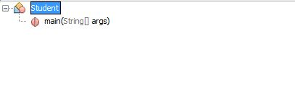

## Figure 2.2.1: Student.java

* **Login.java:**

Login.java is for three types of users showed by a combo box. Admin, faculty oe student must have to login to access the software.

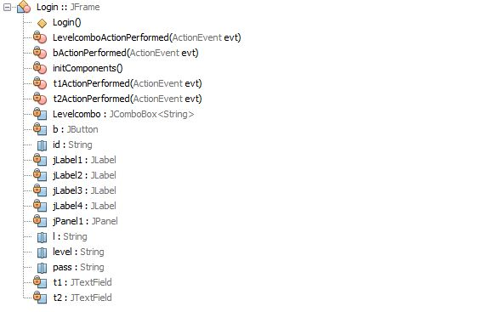

## Figure 2.2.2: Login.java

* Adminpanel.java:

In the login page if admin inputs his/her id and password then the Adminpanel.java page will open.

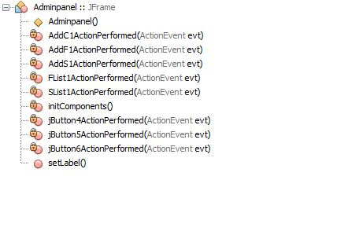

## Figure 2.2.3: Adminpanel.java

* C_insert.java:

C_insert.java is in the admin panel. Courses can be added by this page

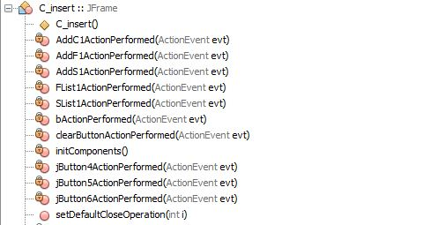.

## Figure 2.2.4: C_insert.java

* C_list.java:

A list of all the courses which were inserted by the admin will be shown here.

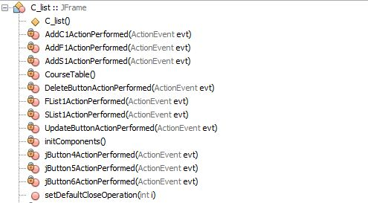

## Figure 2.2.5: C_list.java

* AssignCourse.java:

In this page admin can select course to which he needs to assign students.

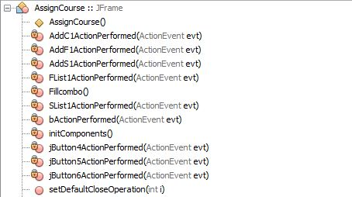

## Figure 2.2.6: AssignCourse.java

* **Scourse.java:**

Using this page, we can assign students to the selected course.

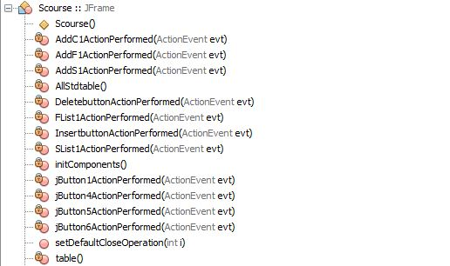

## Figure 2.2.7: Scourse.java

* **F_insert.java:**

Using this page admin can register new faculty.

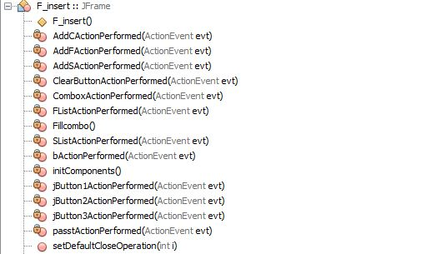

## Figure 2.2.8: F_insert.java

* **Jtable.java:**

In this page admin can see the registered faculty list and also can update, delete and print the list.

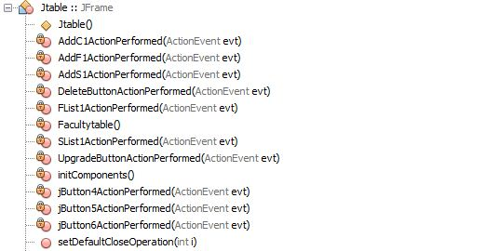

## Figure 2.2.9: Jtable.java

* **S_insert.java:**

If admin wants to add new student, it can be done by using this page.

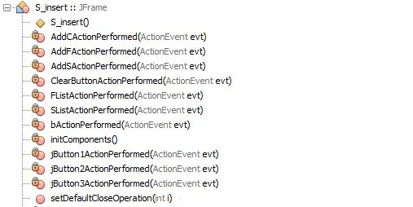

## Figure 2.2.10: S_insert.java

* **S_list.java:**

Registered student list is available in this page. This list can be updated, deleted and printed if necessary.

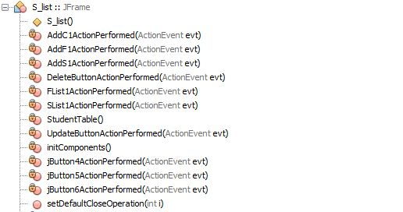

## Figure 2.2.11: S_list.java

* **F_pinfo.java:**

This is the first page of faculty panel that are already registered. This page shows their information and it also has a ‘Grade Submission’ button.

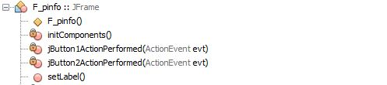

## Figure 2.2.12: F_pinfo.java

* **F_panel.java:**

This is the page which appears after clicking the ‘Grade Submission’ button of the F_panel page. Using this page faculty can submit the grades of students.

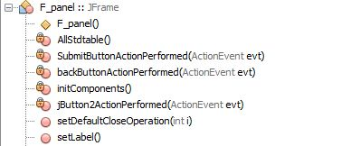

## Figure 2.2.13: F_panel.java

* **S_pinfo.java:**

This panel is for students. All the students who were registered by admin have her/his own panel or page and she/he can see the personal information here. It also has a ‘Get Result’ button.

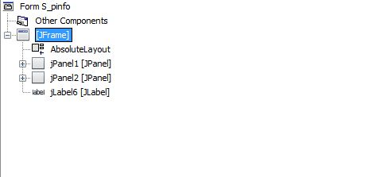

## Figure 2.2.14: S_pinfo.java

* **S_panel.java:**

This page will appear after clicking the button ‘Get Result’ of the S_pinfo page. This page shows the courses those were taken by the student, credit hour and grade of individual courses and then the calculation of total credit hour and CGPA of the student. This way all the students can get their results.

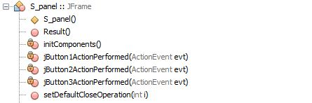

## Figure 2.2.15: S_panel.java

## 2.3 Database and Table Design:

Database design is the process of producing a detailed data model of database. This data model contains all the needed logical and physical design choices and physical storage parameters needed to generate a design in a data definition language, which can then be used to create a database. A fully attributed data model contains detailed attributes for each entity.

The term database design can be used to describe many different parts of the design of an overall database system. Principally, and most correctly, it can be thought of as the logical design of the base data structures used to store the data. In the relational model these are the tables and views.

* CREATE TABLE Admin ( ID int, Name varchar, Contact varchar, Email varchar, primary key(ID) )
* CREATE TABLE "Course" ( `C_Code` Varchar(20) NOT NULL, `C_Name` Varchar(20) NOT NULL, `C_Credit` int(10) NOT NULL, PRIMARY KEY(`C_Code`) )
* CREATE TABLE "Faculty" ( `F_id` INTEGER NOT NULL, `Name` TEXT NOT NULL, `Contact` TEXT NOT NULL, `C_Code` TEXT NOT NULL, PRIMARY KEY(`F_id`) )
* CREATE TABLE "Login" ( `ID` int(8) NOT NULL, `Pass` varchar(20) NOT NULL, `Level` int(2) NOT NULL, PRIMARY KEY(`ID`) )
* CREATE TABLE MAT219( S_id int(8) NOT NULL, Grade Varchar(20), primary key(S_id))
* CREATE TABLE "Student" ( `S_id` INTEGER NOT NULL, `Name` Varchar(20) NOT NULL, `Contact` TEXT NOT NULL, `Email` varchar(20) NOT NULL, PRIMARY KEY(`S_id`) )
* CREATE TABLE csc307( S_id int(8) NOT NULL, Grade Varchar(20), primary key(S_id))
* CREATE TABLE csc347( S_id int(8) NOT NULL, Grade Varchar(20), primary key(S_id))
* CREATE TABLE csc383( S_id int(8) NOT NULL, Grade Varchar(20), primary key(S_id))
* CREATE TABLE csc433( S_id int(8) NOT NULL, Grade Varchar(20), primary key(S_id))

## 2.4 Graphical User Interface Implementation

The SWT Designer provides an easy to use environment for creating the GUI. The source code of the GUI is automatically generated when any graphics was added to the Java file. The code that is generated contains the properties of each individual GUI item. Some methods are created to control the entire GUI. Some methods are implemented to receive signals via serial port of a wireless receiver and redistribute signals via serial port to designated receiver.

1. The first page of our software is login page from where admin or Faculty or Student will login into the main software.

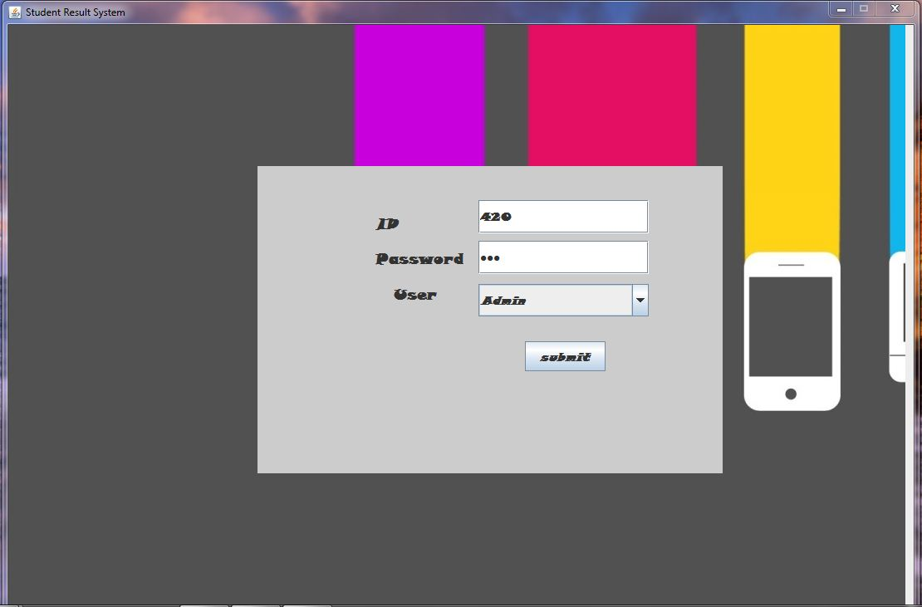

## Figure 2.4.1: Login page

If the user id or password is not correct then a pop-up message will show that the id or password is not correct.

1. Admin can see their own information when she or he just logged in.

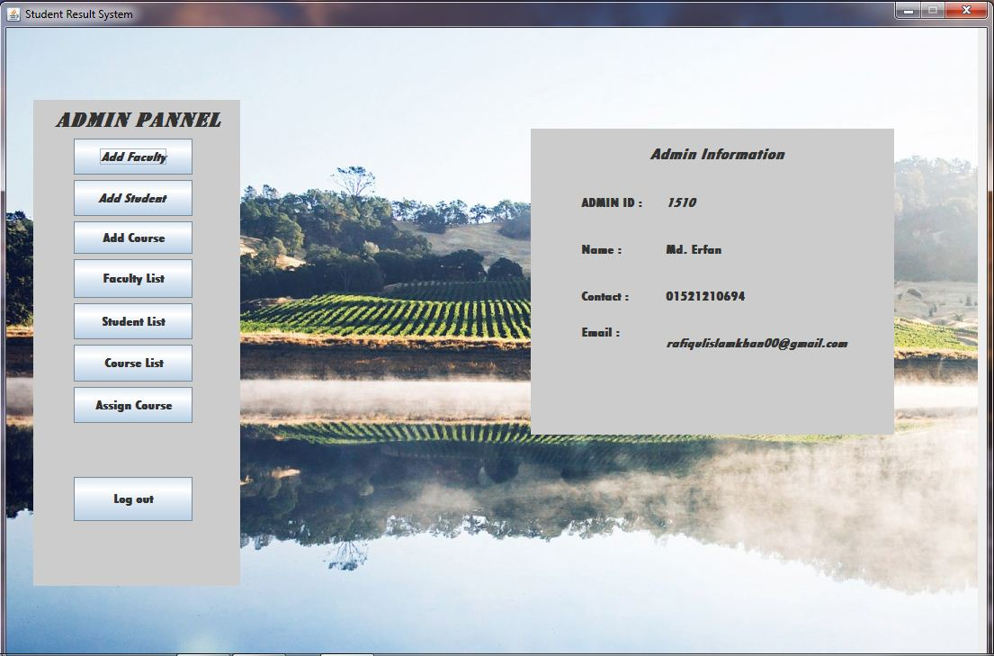

## Figure 2.4.2: Admin information

1. Admin can insert new Faculty with her/his information.

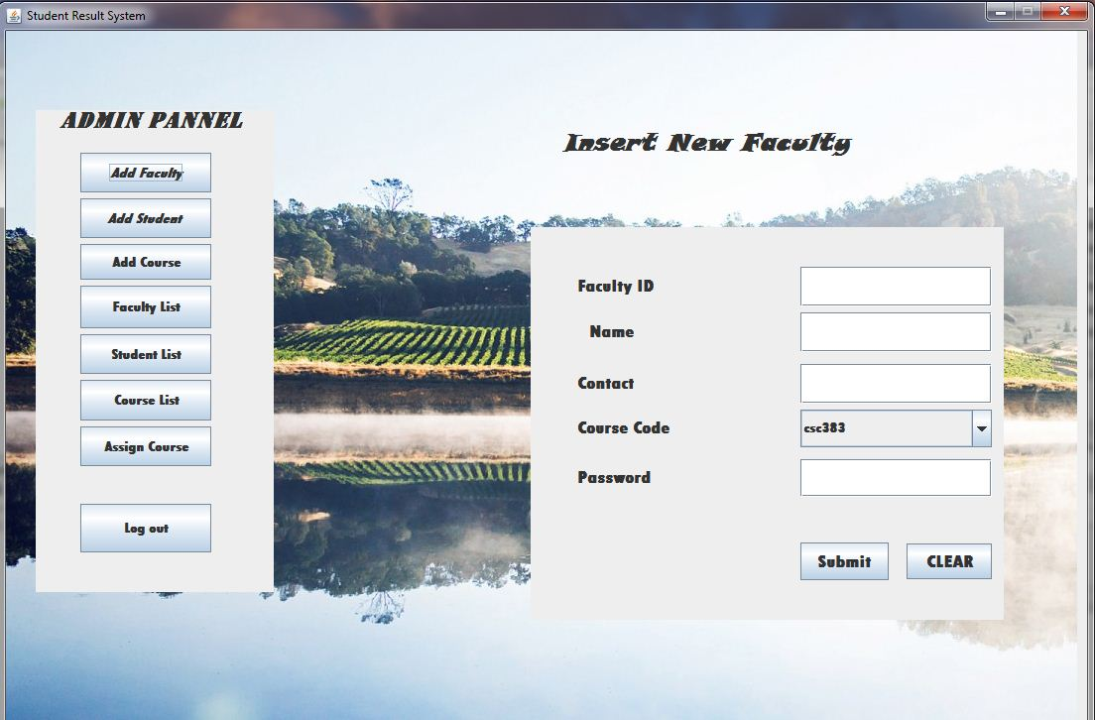

## Figure 2.4.3: Adding Faculty

1. Admin can see all the Faculty information and also update and delete those information and can print those information.

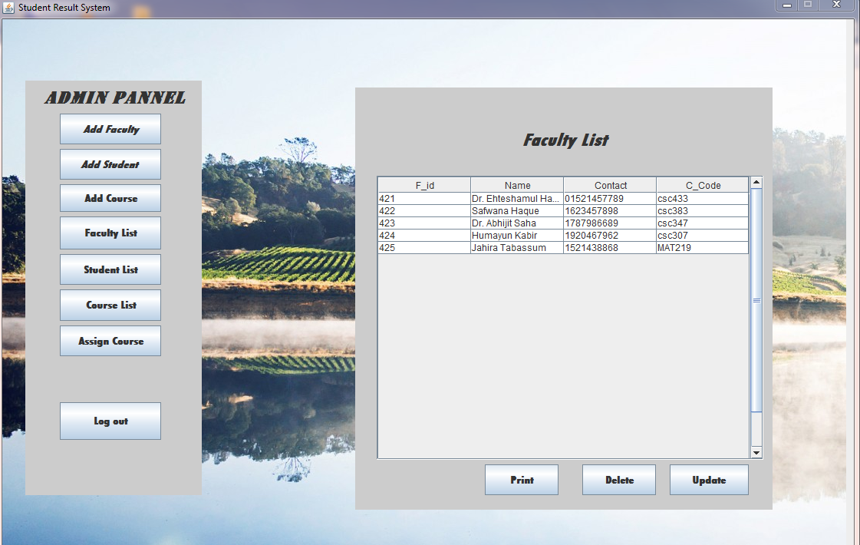

## Figure 2.4.4: Faculty List

1. Admin can insert new student with their information.

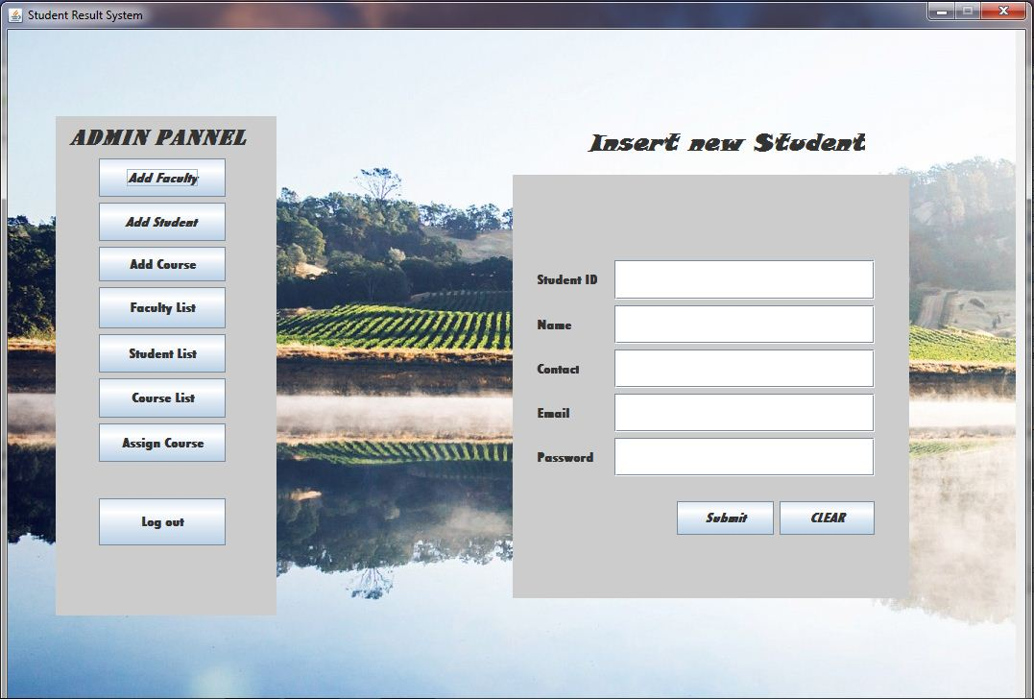

## Figure 2.4.5: Adding new Student.

1. Admin also can update and delete student information and also can see the total student list and can print those information.

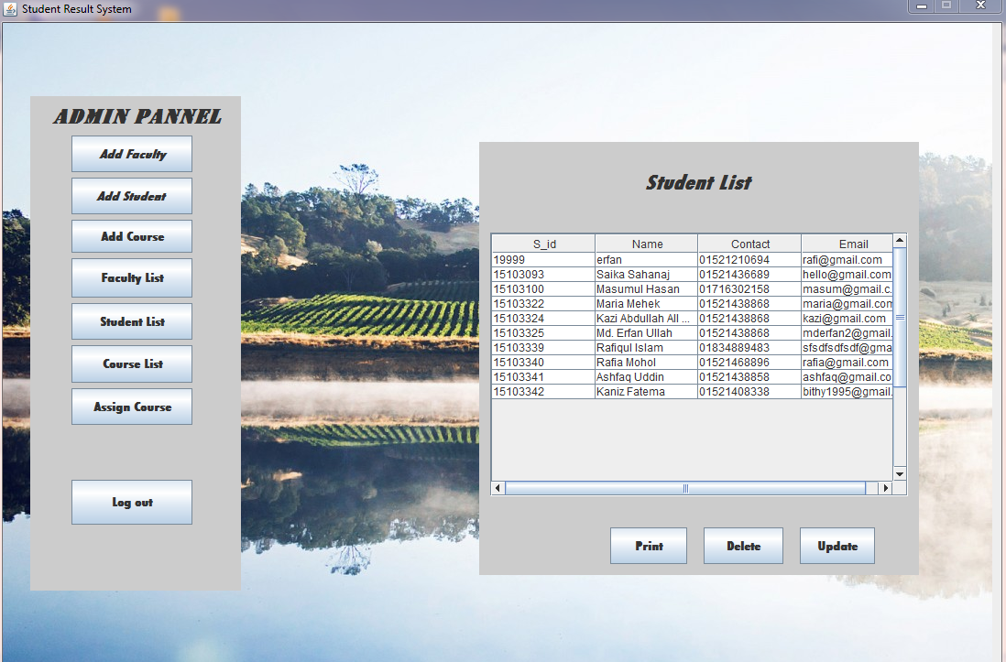

## Figure 2.4.6: Student List.

1. Admin can add courses from their account.

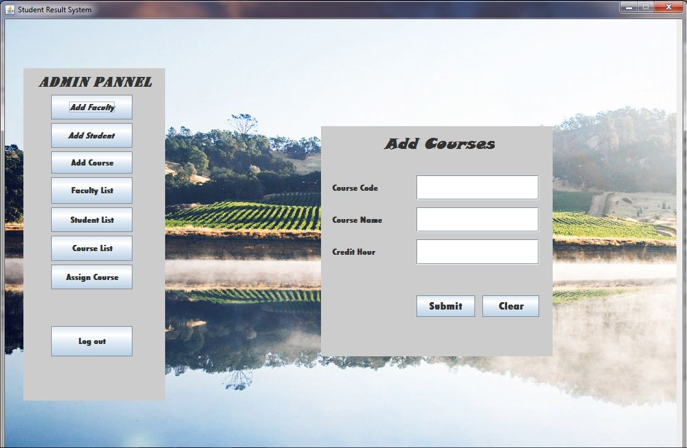

## Figure 2.4.7: Add course Window

1. Admin can see the course list and can update, delete or print the list.

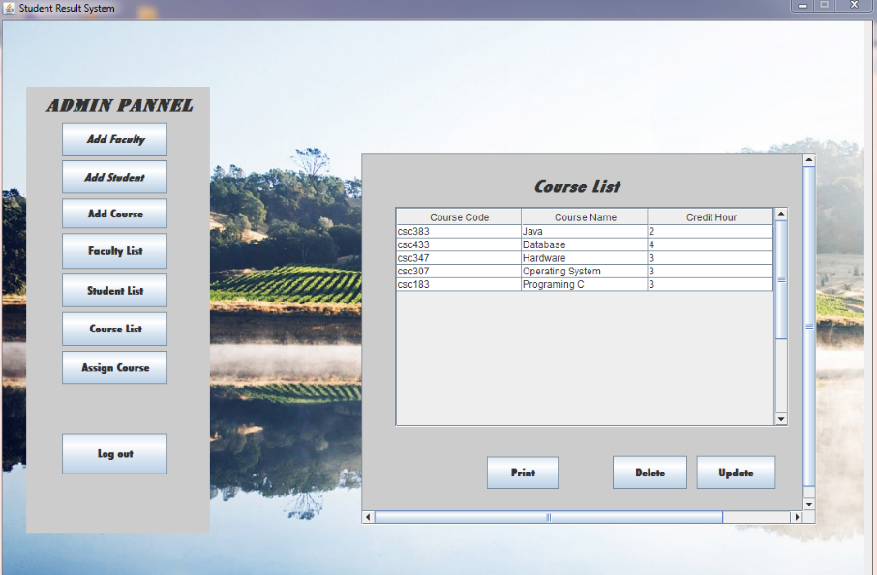

## Figure 2.4.8: Course List

1. Admin can assign student to a selected course.

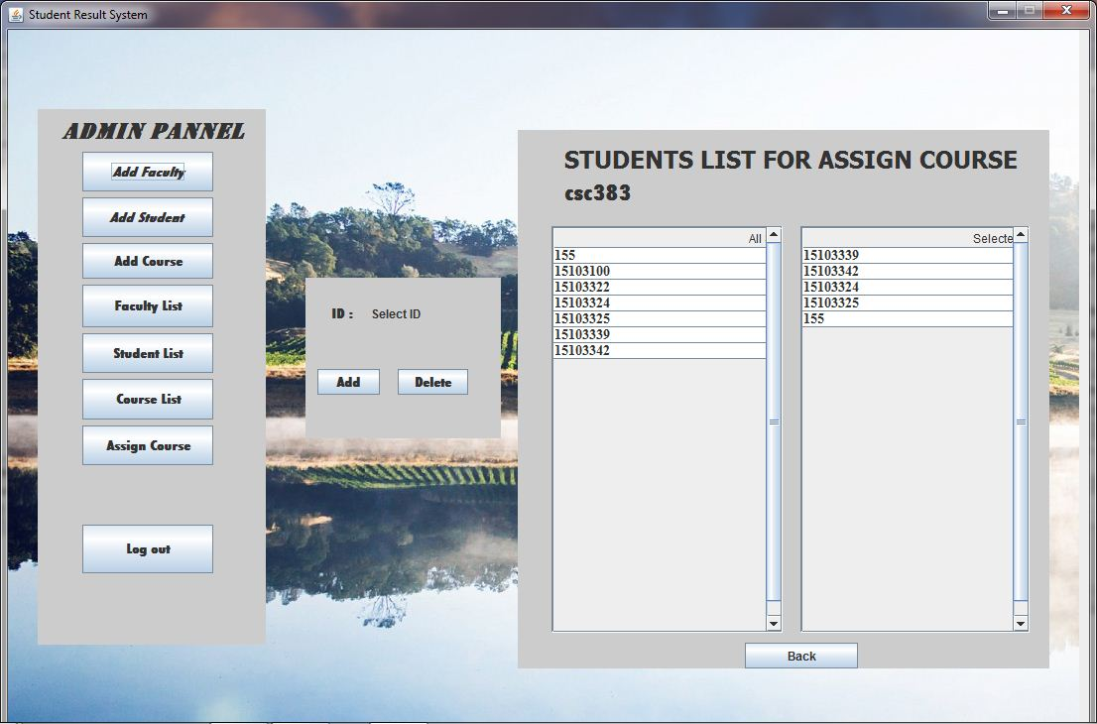

## Figure 2.2.9: Assign Course

1. When faculty login by giving her/his id and password, her/his information will be shown in the first page. If the ‘Grade Submission’ button is clicked, a new page will appear by which faculty will be able to submit the grade of students.

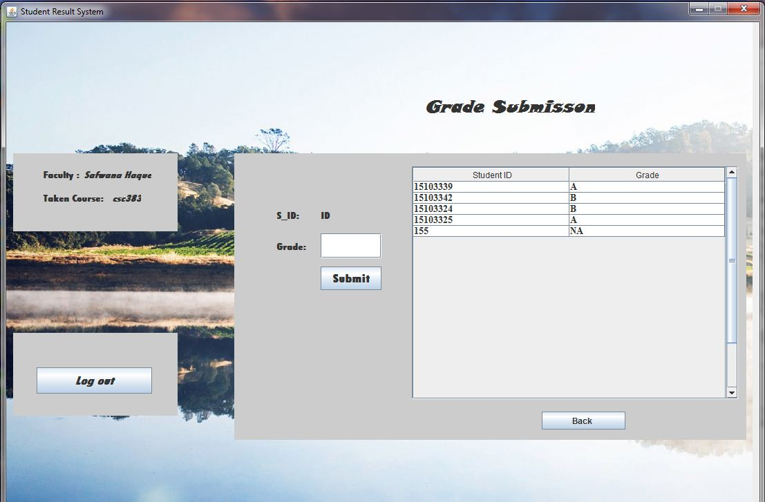

## Figure 2.4.10: Faculty Profile

1. Faculty can submit the student’s grades by this page.



## Figure 2.4.11: Grade submission

1. Students will see their information after login and clicking the ‘Get Result’ button will show a new page.

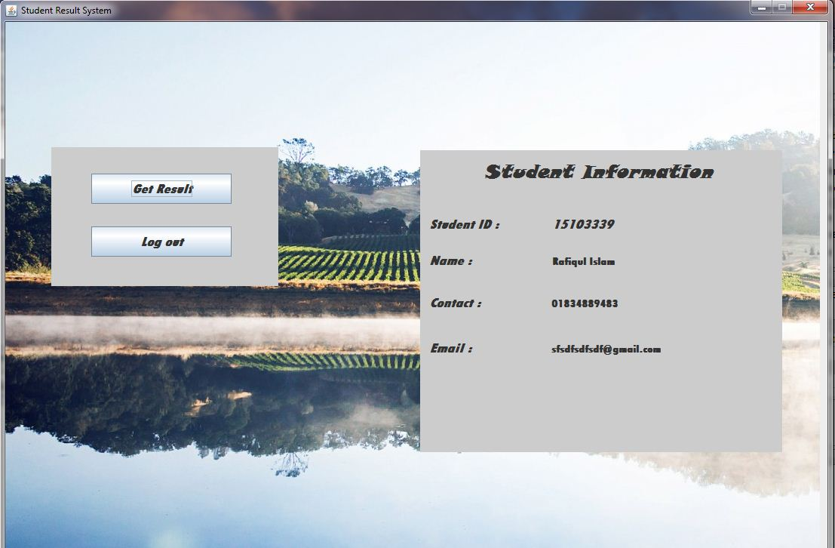

## Figure 2.2.12: Student Information

1. Students can find their results by this page.

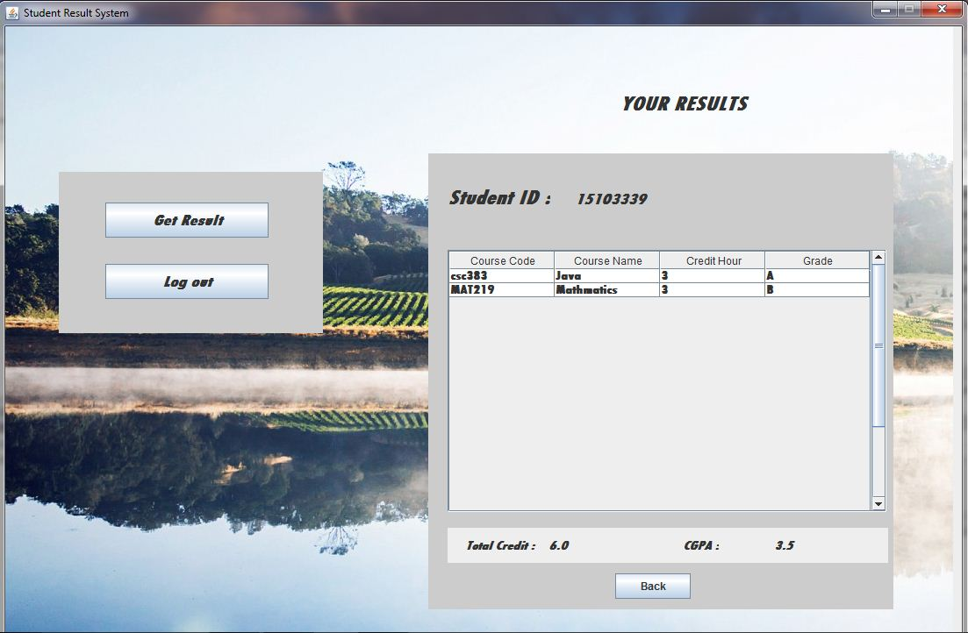

## Figure 2.4.13: Result

# Critical Evaluation

Admin can add course, faculty and student and also can see or update, delete, print the list of course, faculty and admin. Admin can assign courses to students and give a course to a faculty. Admin has all the power.

Faculty can see her/his own information and can submit the grades of students. Students can see her/his information and can see the result and total credit hour also.

This application is able to keep record of each individual faculty and student information and print the information if needed.

# Bibliography:

1) NetBeans. (2015) Writing JUnit Tests in NetBeans IDE. Available at: http://ww.netbeans.org/kb/docs/java/junit-intro.html (Accessed 12th March, 2017)

2) w3schools. (2015) mysql tutorial. Available at: https://www.w3schools.com/sql/ (Accessed 17th March, 2017)

3) Regular- Expression. (2015) Regular Expressions quick start. Available at:

http://docs.oracle.com/cd/B28359_01/appdev.111/b28424/adfns_regexp.html (Accessed 28th March, 2017)

4) Connecting to a database table. Available at: http://www.makeuseof.com/tag/learn-sql-simple-database-sqlite/ (Accessed 28th March, 2017)

5) How to create PDF file in Netbeans Java Projects. Available at:

https://www.youtube.com/watch?v=2852BXYimj4 (Accessed 3rd April, 2017)

6) Insert, Delete and Update. Available at:

7)